**Internshala**



Airline Data Management and Analysis using Power Bi

**2025**

Submitted By:   
Saraswathi Gongala

**Problem Statement:**

The airline industry operates with numerous complexities, requiring effective data management and insights into flight schedules,

Passenger details, and ticketing systems. This project aims to analyze airline operations for improving efficiency and customer Satisfaction.  
  
**Task 1: Data Preparation and Cleaning**

During this process, I loaded Power Query Editor in Power BI with the three datasets (Flight_Information, Passenger_Information, and Ticket_Information).

**Steps Taken:**

* Imported data into Power Query for each table.
* Removed duplicates from all datasets (i.e. duplicate passenger or flight records).
* Dealt with missing values: For example, null Status fields are replaced with "Unknown", null or blank Seat-Number entries were filled with NA
* Formatted the column data types (i.e. FlightDate columns converted to Date, PassengerID converted to text).
* 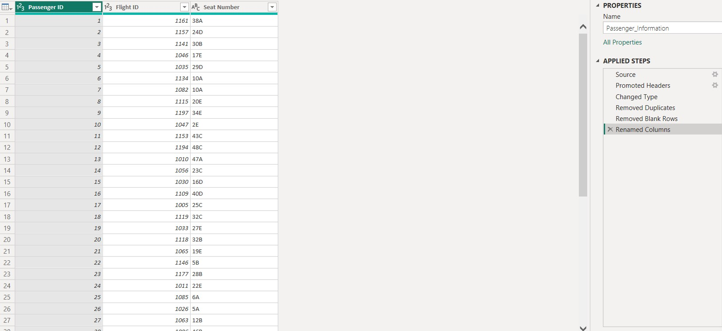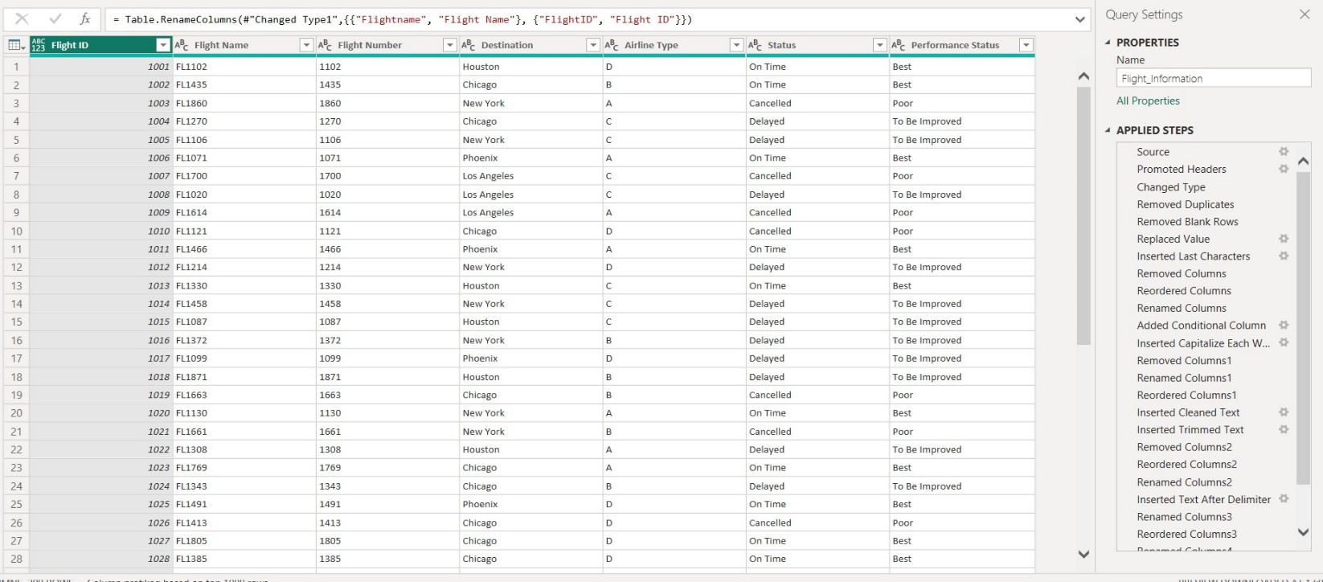Renamed columns for readability and consistency (i.e. FlightID to Flight ID, BookingStatus to Booking Status).

**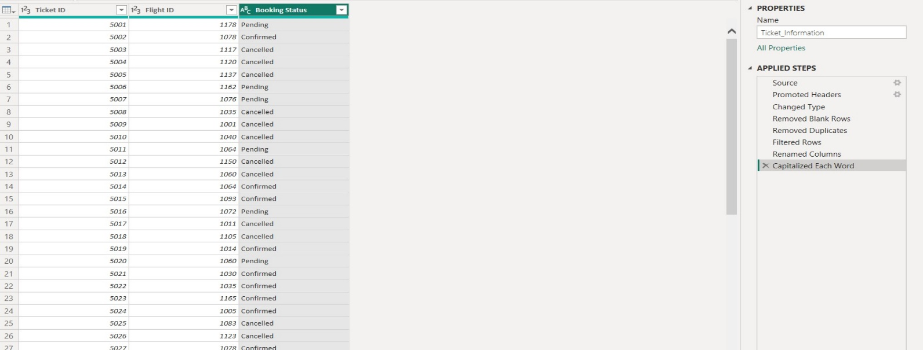  
  
Task 2: Data Modeling**

After cleaning the data, I uploaded it into Power BI. Then I created a data model, using the Flight ID field as the primary key to relate the three tables**.**

**Steps Completed:**

Connected**:**

* **Flight_Information[Flight ID] ↔ Passenger_Information[Flight ID]**
* **Flight_Information[Flight ID] ↔ Ticket_Information[Flight ID]**
* Used One-to-Many relationships when needed.
* Verified the cardinality and referential integrity to validate accurate filtering and aggregated results across related tables.

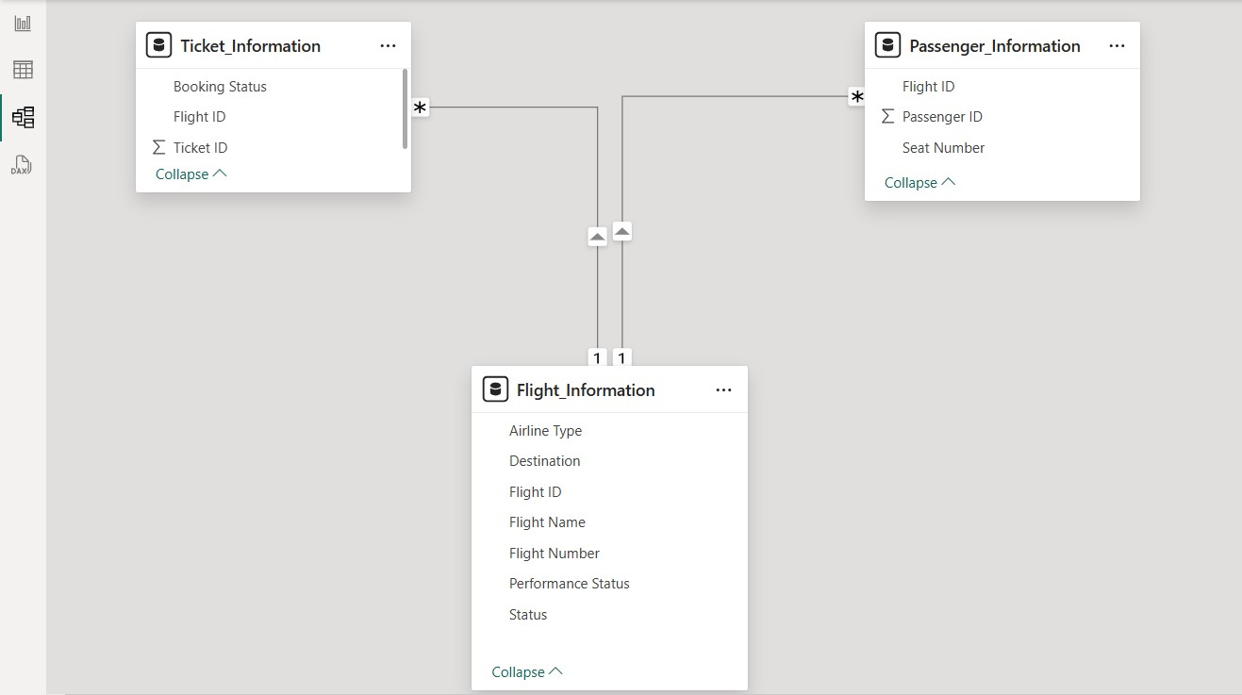

**Task 3: New Insights - Enrichment of Data Insights**

In this task I focused on data enrichment by adding new insights using various features of Power Query.

**Enhancements**:

* Conditional Column: Added a column called “Performance Status” which classified individual flights:

If the Status = "On Time" → Best   
 “Delayed” → to be improved   
 “Canceled” → Poor

* Column from Examples: 'Column from Examples' feature of Power BI was used to extract the flight number (e.g numeric code) from Flight Number and renamed the original as Flight Name.

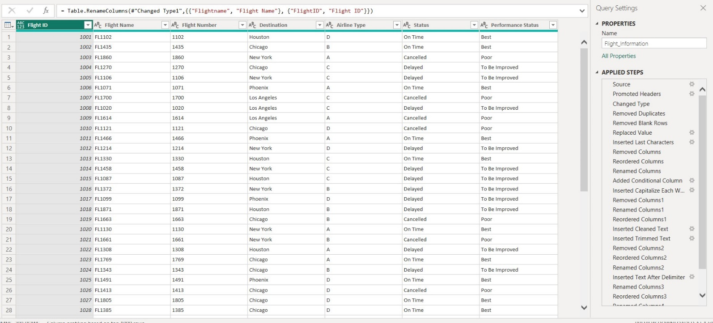

**Task 4: Calculations Using DAX**

In this task, I was able to use DAX (Data Analysis Expressions) for creating measures and calculated tables to create certain metrics that were meaningful and dynamic for the analysis**.**

**Key Calculations:**

**1-Total Passengers for a Specific Flight**

I created a measure to calculate the number of passengers associated with a specific flight using the CALCULATE function. First I created a “Total Passengers” Measure to calculate the total passengers. After that used calculate function and filtered flight ID to get a specific result, making it interactive and context-aware.

**DAX**: **Total Passengers for specific flight = CALCULATE ([Total passengers],Passenger_Information[Flight ID])  
  
2-Total Tickets Booked**

I used to the “DISTINCTCOUNT” function to determine the total number of unique tickets in the data. This will prevent counting any duplicate “Ticket ID” which keeps the booking totals accurate.

**DAX: Total Tickets = DISTINCTCOUNT(Ticket_Information[Ticket ID])  
  
  
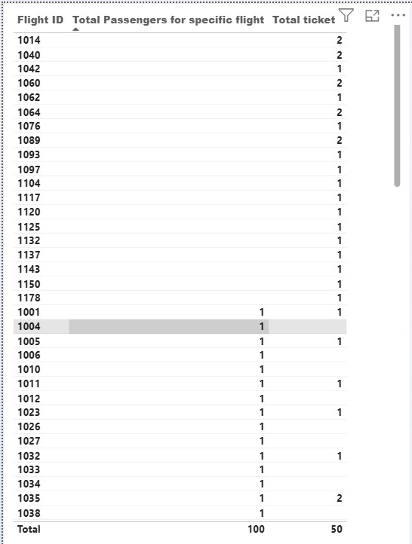**

**3. Filtered Table: Best Flights**

To do an analysis of only the best-performing flights, I created a new DAX table (not a visual filter or a measure). This table filters the “Flight Information” dataset to include only the records in which Performance Status equals "Best".

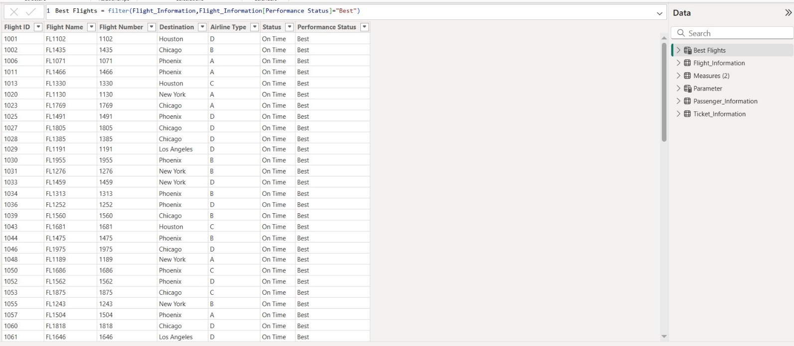**DAX: Best Flights = FILTER(Flight_Information,Flight_Information[Performance Status] = "B  
  
Task 5: Visualizations and Interactive Options**

This task was centered on converting the cleaned and modeled data into interactive visualizations or dashboards that let users slice data in different views while providing insights into the performance of airlines, passenger demographic spread, and booking patterns.

**🔹 Visuals Designed:**

Passenger Count by Airline – This was communicated with a Clustered coloumn chart showing the total number of passengers that each airline served.

Ticket Booking Statuses – This was illustrated using a donut chart showing the totals of tickets that were booked, cancelled, and pending.

Flights by Airline and Destination – This was visualized using a clustered column chart which shows the number of flights each airline has operated to each destination.   
  
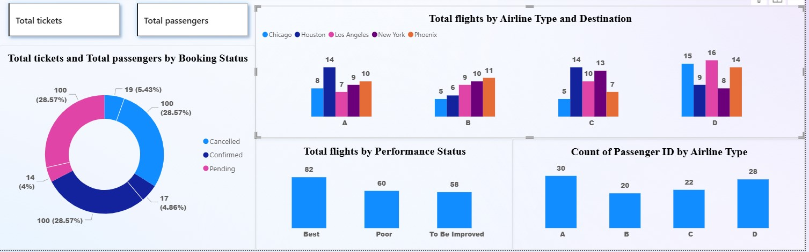 **🔹 Interactivity Options Developed:**

**Slicers were built to allow users to filter data by:**

* Destination
* Airline

**Bookmarks were built to create a simulated Quick Views with bookmarks such as:**

* Location & Airline type

**Drillthrough Pages were also created to drill down into each airline's dashboard.**

* For example, if "Airline A" was clicked, they would navigate to the page where that airlines performance metrics, passengers, and bookings will be shown.

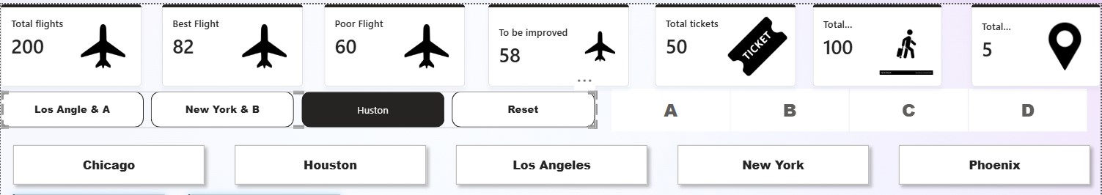

**Complete Report Page:  
  
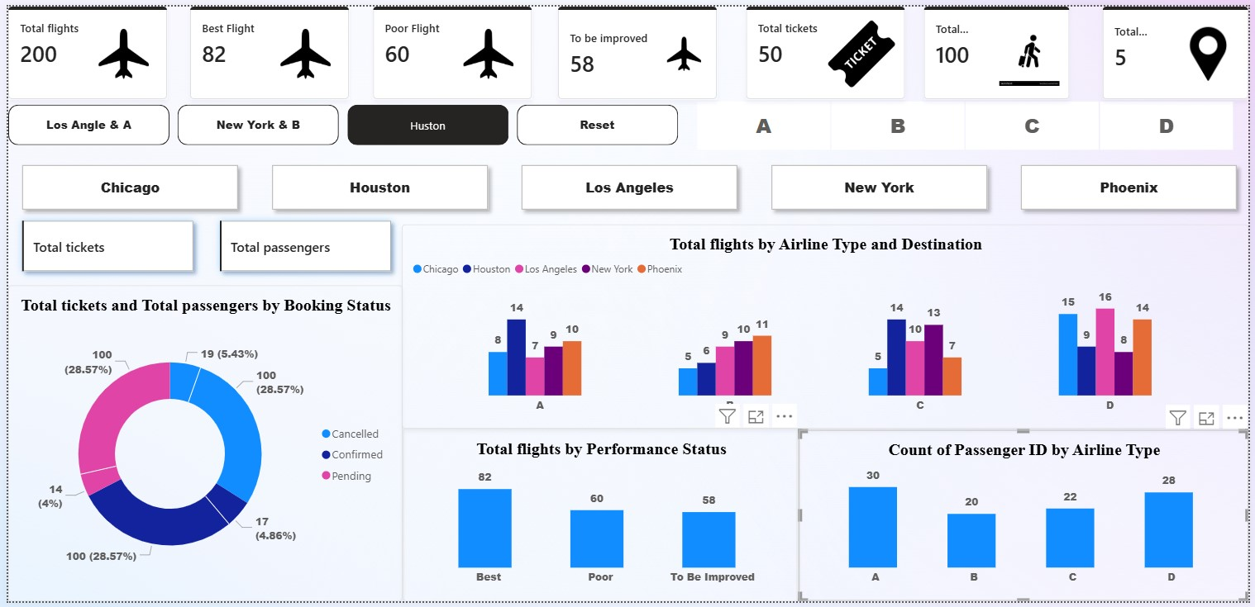**

**Airline Specific Page:  
  
  
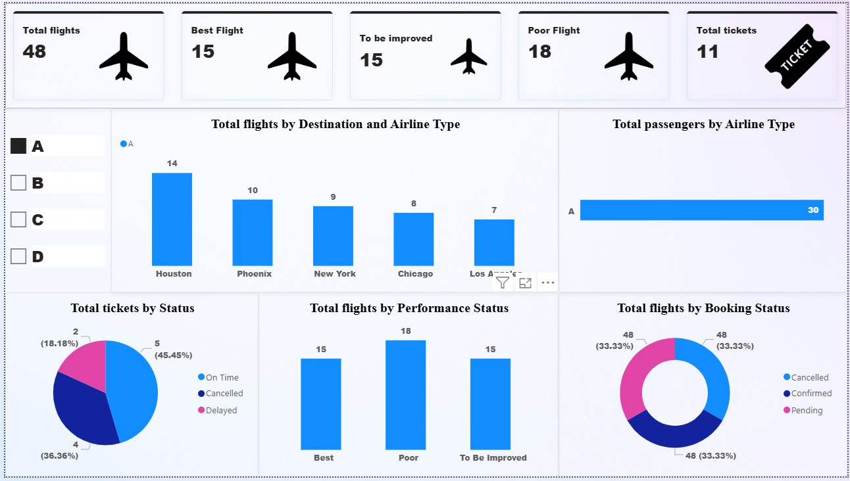**

**Decomposition Tree:  
  
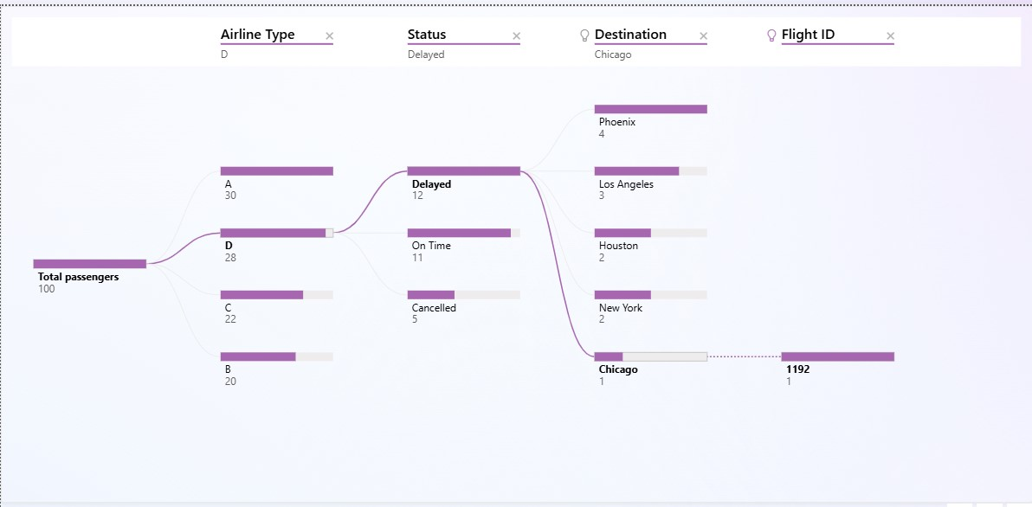**

**Drill Through:**

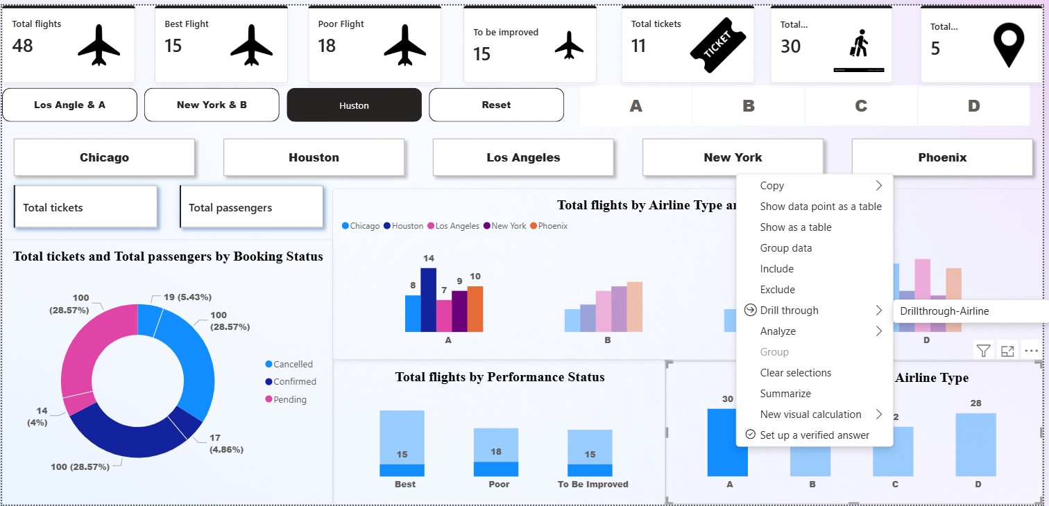

**6. Final Dashboard and Power BI Service**A final dashboard was developed in Power BI Desktop and published in Power BI Service.

**Key Activities:**

Development of a summary dashboard that displayed:

* Total Flights
* Passenger Volume
* Booking Status Distribution

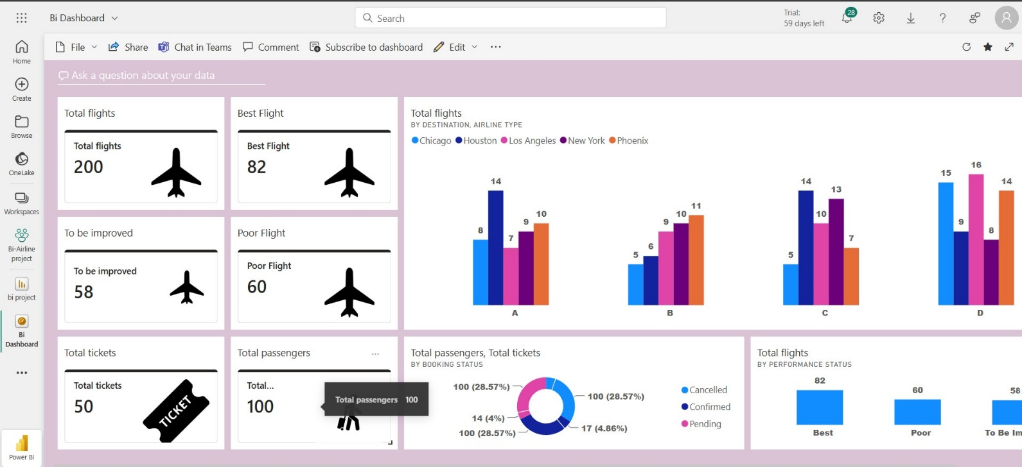

**Row Level Security (RLS) Activity:**

* RLS was set-up to ensure that the data that the current user could view was limited to only "Airline A"
* A role was created and assigned to a test user on the Power BI Service.  
    
  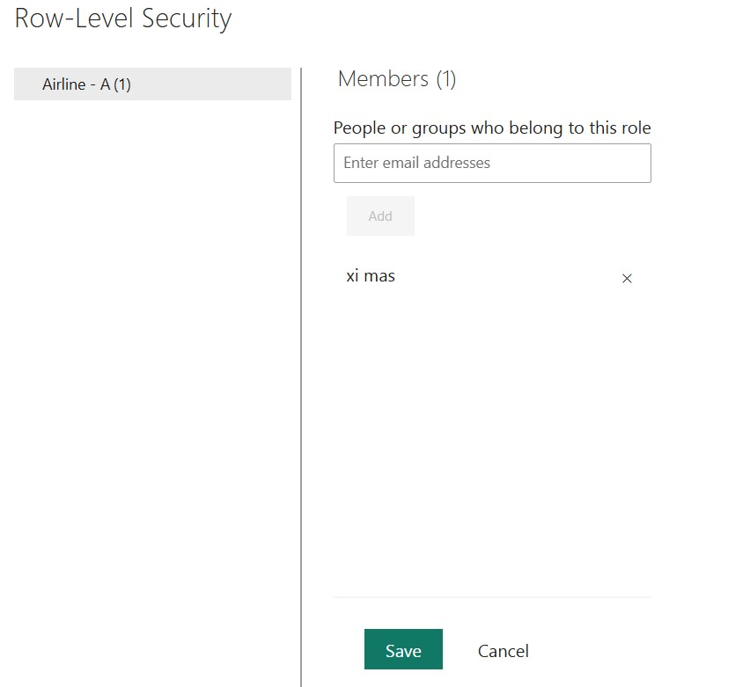

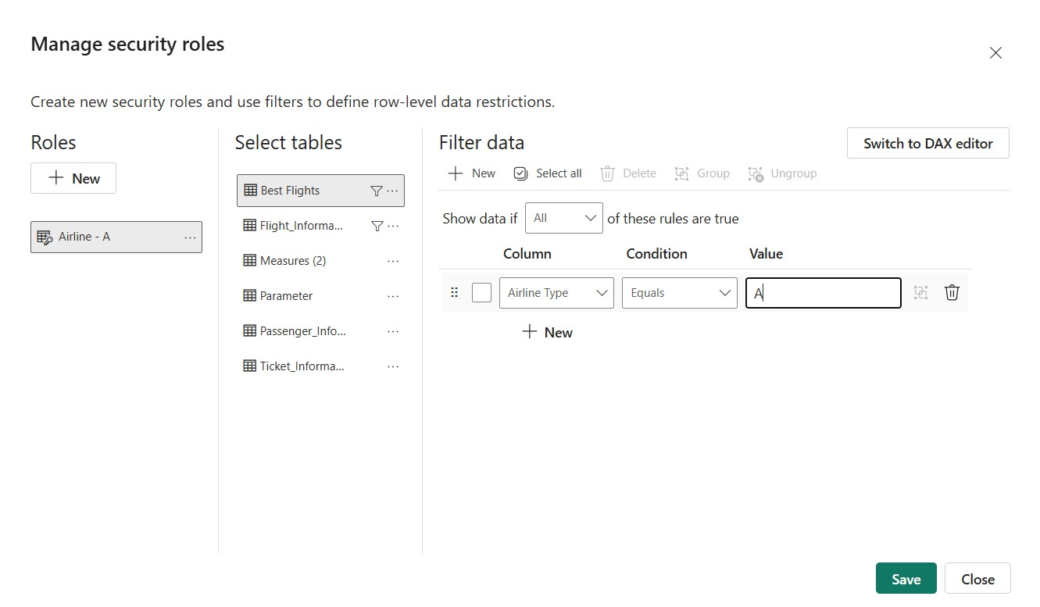

  
  
  
**Scheduled Data Refresh:**

* 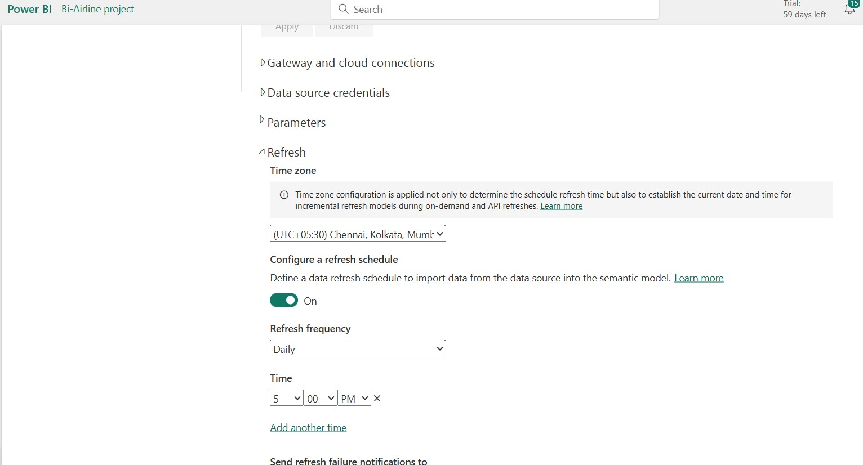Made configuration for a daily refresh for the dataset at 5:00 PM in Power BI Service

**Final** **Thoughts**

This project illustrates the power of Power BI to convert unprocessed airline data into actionable business intelligence. Each data ingestion to deploying the dashboard was done to support real-world analytics objectives — enhance operational transparency and better inform decision-making for airline management.   
  
  
  
Thank you  
Video Link: https://drive.google.com/file/d/1xl-FfngraPIvN35yDAHmeYiexj_YGZfU/view?usp=sharing